**Instructional Manual**

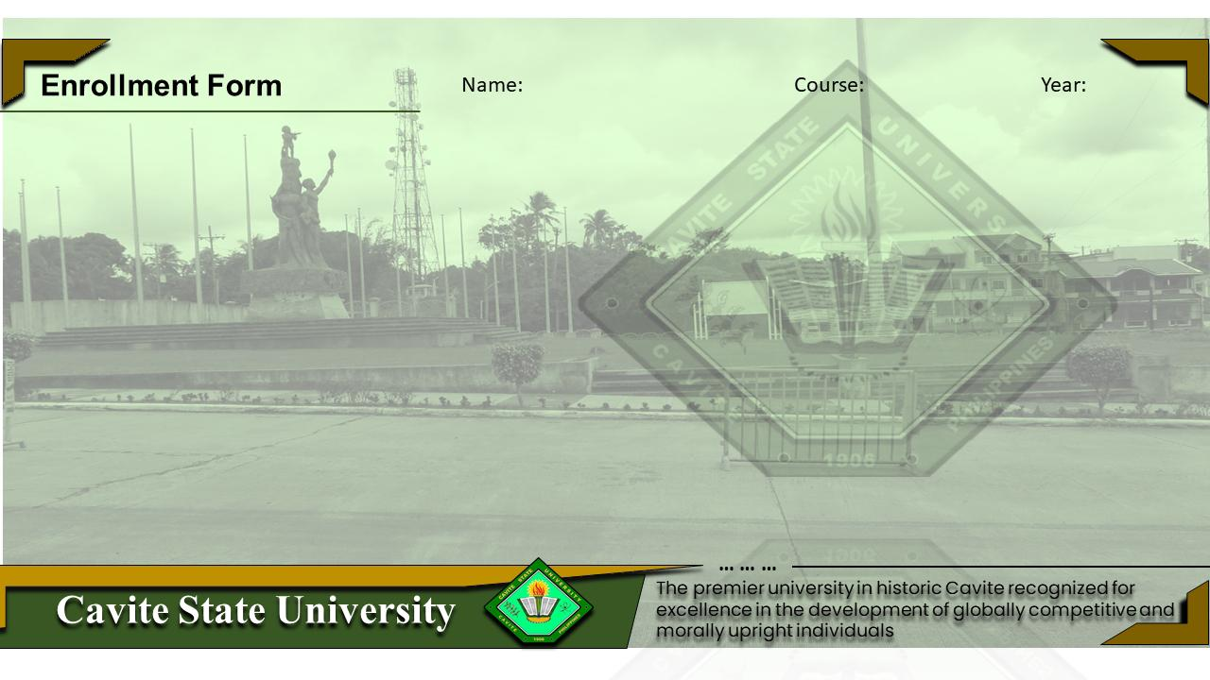

**CvSU Enrollment Form**

**Prepared By:** Group 1 of BSIT 1-6 .

**Date:**  November 30, 2022 .

**PREFACE**

*About This Manual*

*This manual is intended for new users with little or no experience using the Cavite State University (CvSU) Enrollment Form System. The goal of this document is to give a broad overview of the main functions of the Cavite State University (CvSU) Enrollment Form System and some basic instructions on how to set up and administer an enrollment. This document will concentrate on demonstrating the step-by-step guide. An effort has been made to ensure that this document is an accurate representation of the functionality of the CvSU Enrollment Form System. As with every software application, development continues after the documentation has gone to press, so small inconsistencies may occur. We would appreciate any feedback on this manual.*

*.*

**GENERAL INFORMATION OF SYSTEM**

*The Cavite State University (CvSU) Enrollment Form System is intended for new and current students and school administrators to make the application for enrollment at the university easy and accessible for everyone. Our goal is to make the enrollment services accessible and usable for the student community. To that end, our documentation includes features that make information available to users of assistive technology. Our system database will automatically generate a.txt file that will save the inputs of the user directly to our server once the enroll button is pressed.*

**STEPS FOR SYSTEM FUNCTIONS**

1. *Enter the program to be direct to the homepage of CvSU Enrollment Form System*

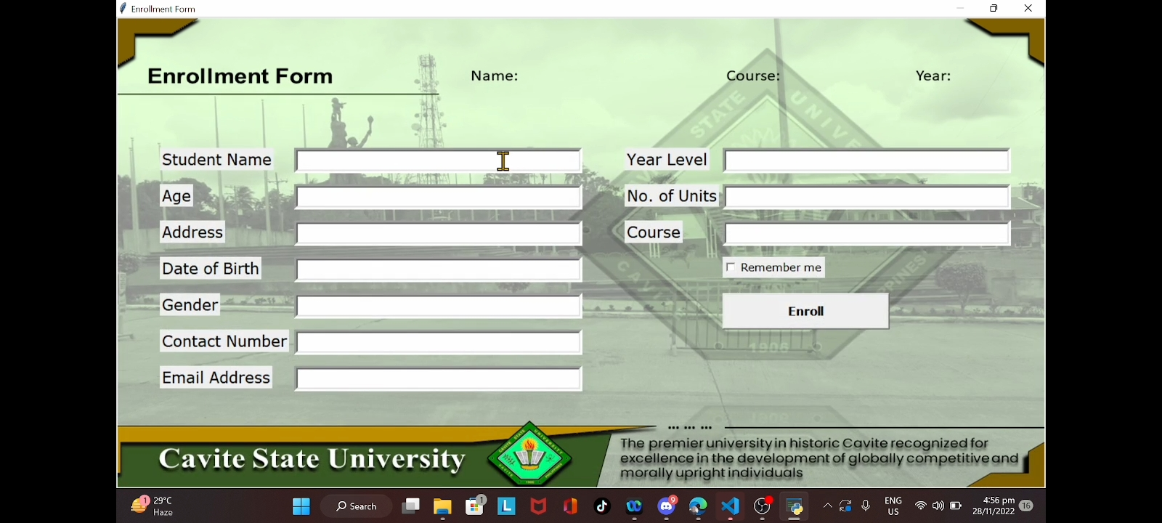

*2. Type and enter basic information such as name, age, complete address, birth info, gender, contact number, email address, and year, units, course that desired to be enrolled. Then click “Remember me” button.*

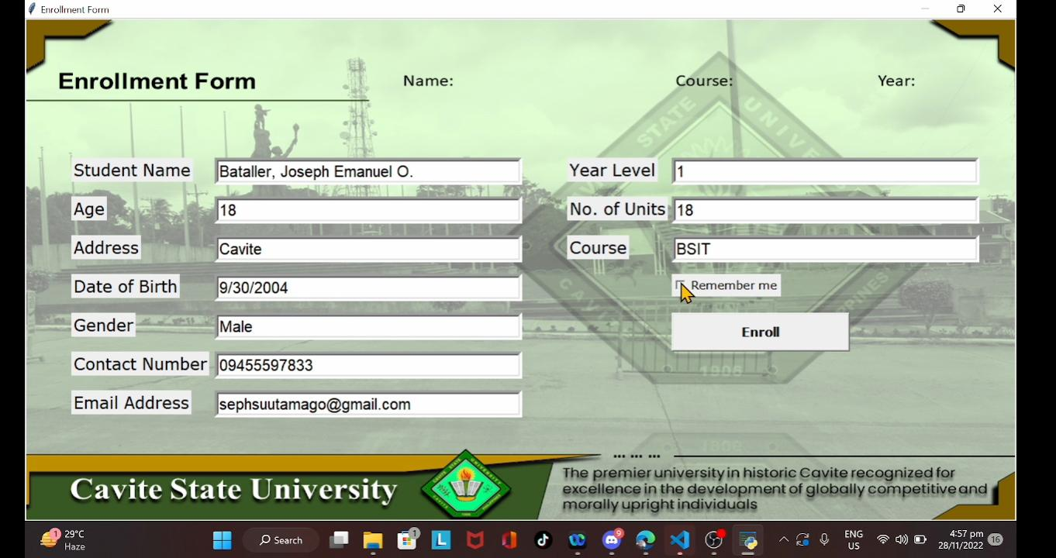

*3. Once the form is fully filled out, click the “Enroll” button. If it is successfully submitted, “Required Information Acquired” will show under the enter button. And your name, course, and year will be displayed at the top of the screen. You can also click the “Show Tuition Fee” button to see estimated tuition. Once done, all of the entered data will be generated in the database and saved.*

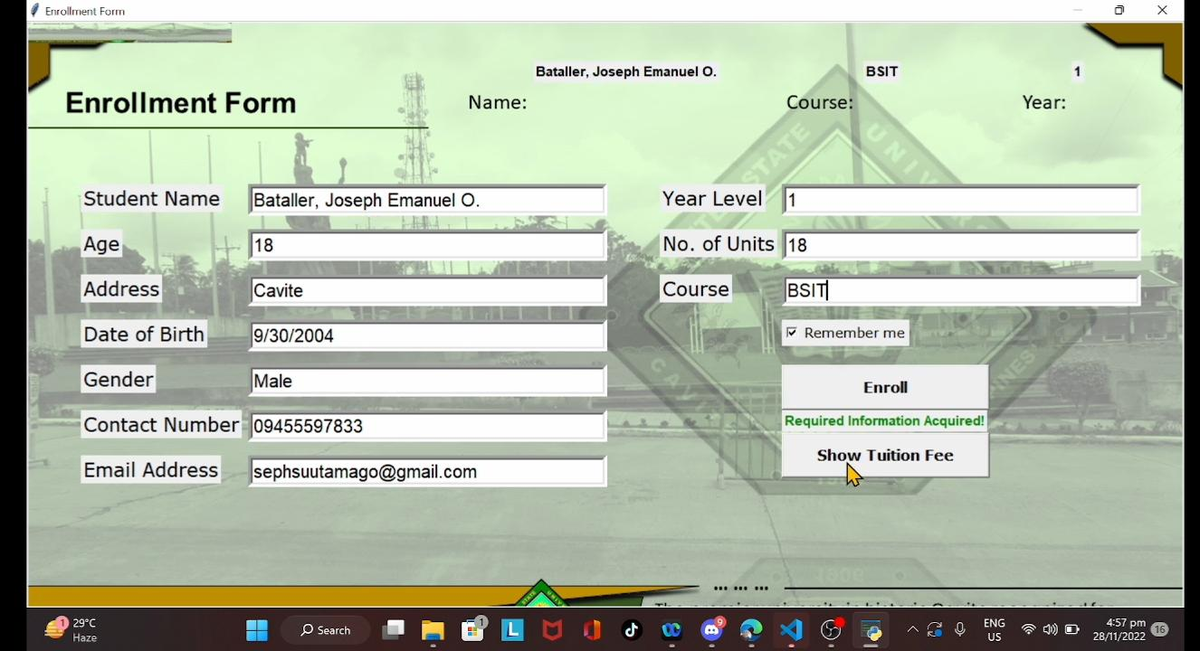

*NOTE: Every line should be filled up for it to be successfully submitted. If not, “All Information Must Be Filled Up” will show under the enter button, and the data entered will not be submitted.*

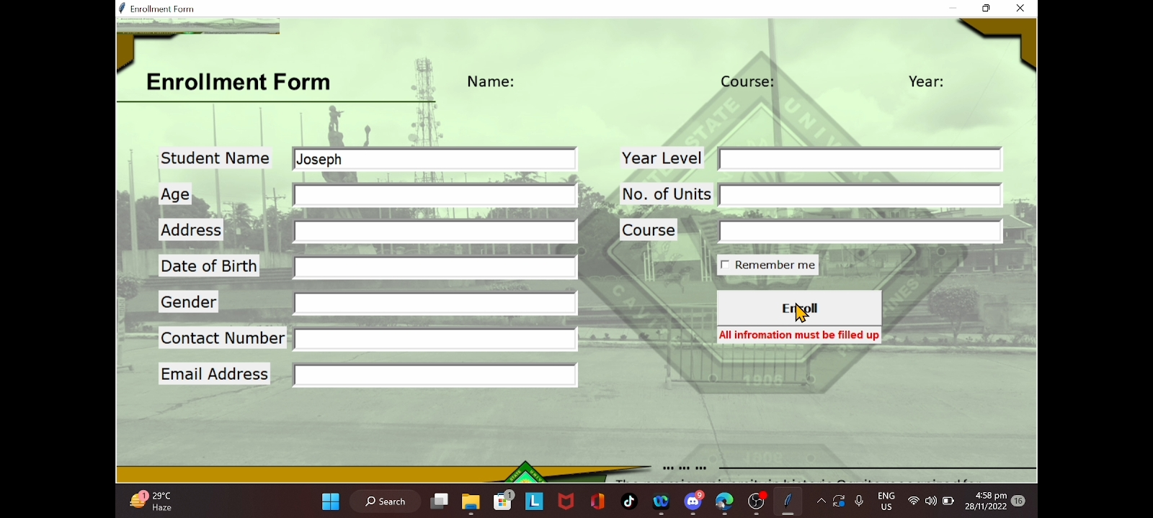

**POINTS OF CONTACTS**

*For inquiries and questions you may reach us at;*

*Facebook: /katrinamae.apostol*

*Email: tmc.katrinamae.apostol@cvsu.edu.ph*

*Cellphone No.: 09677 112142*